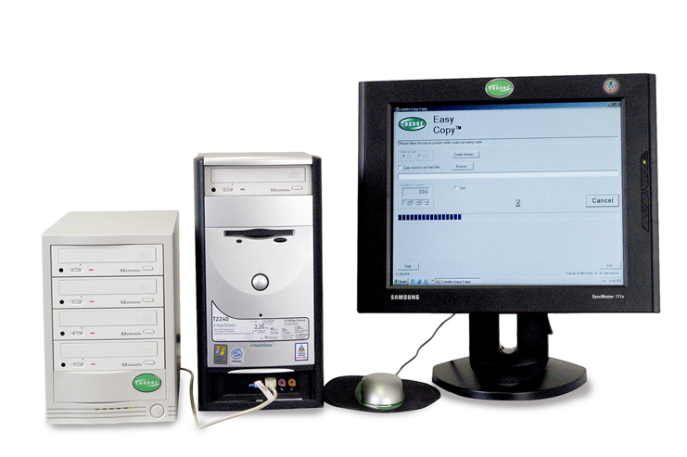

Simple Copy 4 System from Condre
Features:

•FOUR CLICK SOFTWARE OPERATION TO DUPLICATE
CD’S OR DVD’S
•SINGLE USB 2.0 CONNECT TO PC, SIMPLE TO INSTALL
•LOW PRICE POINT
•SIMPLE SOFTWARE INSTALLATION
•DISC TO DISC COPY OR COPY FROM HARD DRIVE
•CREATE MASTER IMAGE ON HARD DRIVE
•52X CD WRITE SPEED, 8X / 8X / 24X DVD WRITE SPEED
•SUPPORT FOR CD R / RW, DVD – R, DVD + R

Specifications:

HEIGHT: 10 1/4"
WIDTH: 7”
DEPTH: 15 1/2"
WEIGHT: 23 LBS
• 300 WATT UNIVERSAL POWER SUPPLY
• 6 FOOT USB 2.0 CABLE
• (2) INDUSTRIAL STYLE COOLING FANS
15151 Technology Drive • Eden Prairie, MN 55344
952-294-4900 • Fax: 952-937-8365
www.condre.com
The Simple Copy 4 System is a new, revolutionary way to duplicate CD or DVD - + R discs. Featuring a simple to use GUI interface, USB 2.0 connection to a PC, and extremely low cost, the Simple Copy 4 System brings CD or DVD duplication capability to a new class of Endusers. The Simple Copy Software, designed by Condre’s experienced Engineering Team, prompts the user through a streamlined four step process during the actual duplication of CD’s or DVD’s. The CD or DVD tower configuration easily connects to the PC via one USB 2.0 cable, similar to any desktop Laser Jet printer. Most importantly, the Simple Copy 4 system is available at a price point affordable for virtually any User. Now available from the leader in CD and DVD R Duplication, Condre, Inc.

Simple Copy 4 System

